DSA Problems and their solutions

Date : feb 17

Q : Print the permutations of string , number .

IP : abc
OP : abc ,acb,bac ,bca,cab ,cba

Intuition :
we generally have choice equal to number of characters in each level
choose one chracter and call the function with the remaining characters

use the loop to extract each character and make call

Sol :
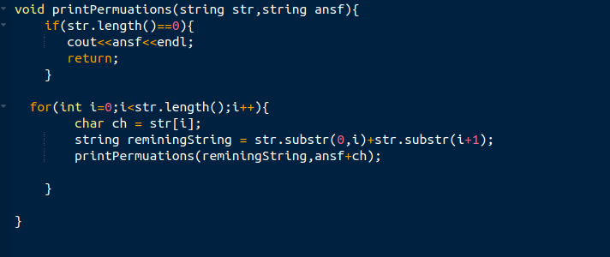

Q :A message containing letters from A-Z can be encoded into numbers using the following mapping:
'A' -> "1"
'B' -> "2"
...
'Z' -> "26"
To decode an encoded message, all the digits must be grouped then mapped back into letters using the reverse of the mapping above (there may be multiple ways). For example, "11106" can be mapped into:
- "AAJF" with the grouping (1 1 10 6)
- "KJF" with the grouping (11 10 6)
Note that the grouping (1 11 06) is invalid because "06" cannot be mapped into 'F' since "6" is different from "06".
Given a string s containing only digits, return the number of ways to decode it.
The test cases are generated so that the answer fits in a 32-bit integer.

Variation 1 :
print the encoding using recursion

Intution :
take one character and add it it answer and pass remaining string
take two character add those into anser if they are <=26 and pass rem str

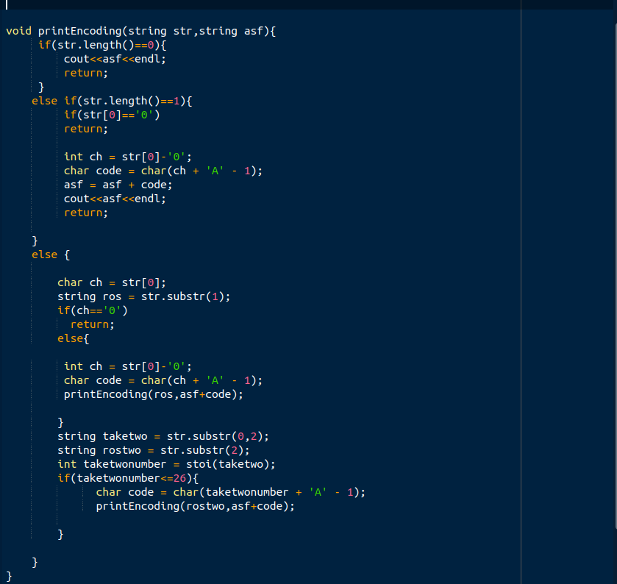

variation 2: return the no of ways to encode only (on leetcode) using plain recursion only
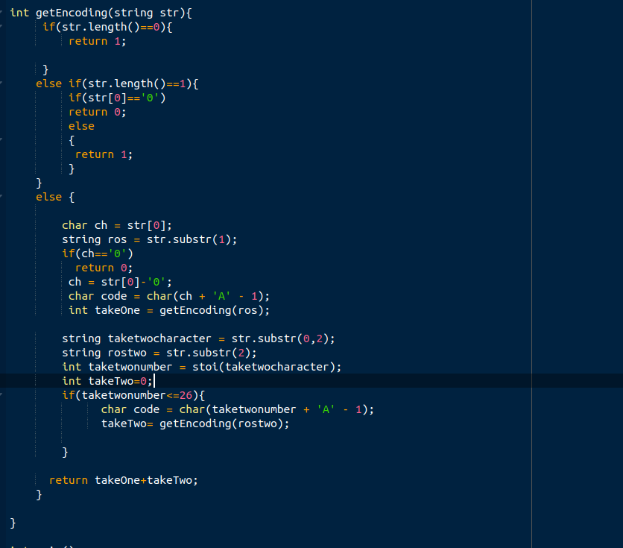

Optimized Solution using DP:
Check which parameter are getting change

Flood Fill Algorithm Pepcoding (Backtracking Logic)

 | 1
 | 1 |  | 1 | 1
1 |  |  | 1
1 |  |  |  | 1
1

We need to print the t,l,d,r instructions to reach at the end

void printPaths(int maze[][],int sr,int sc,int r,int c,string psf,bool visited[][]){

if(sr < 0 || sc < 0 || sr > r || sc > c || maze[sr][sc]=1 || visited[sr][sc]){
return ;
}

}

18 feb

You are given the head of a singly linked-list. The list can be represented as:
L0 → L1 → … → Ln - 1 → Ln
Reorder the list to be on the following form:
L0 → Ln → L1 → Ln - 1 → L2 → Ln - 2 → …
You may not modify the values in the list's nodes. Only nodes themselves may be changed.

Example 1:
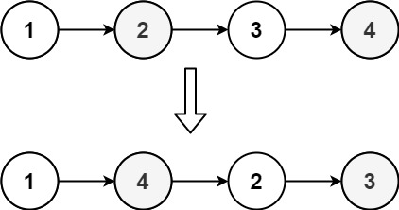
Input: head = [1,2,3,4]
Output: [1,4,2,3]
Example 2:
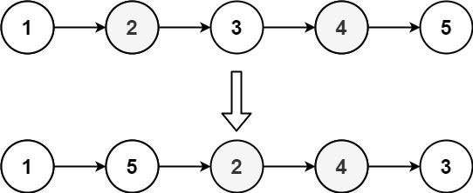
Input: head = [1,2,3,4,5]
Output: [1,5,2,4,3]

Solution(Not optimized solution) :
We are using extra space here to keep the track of all the nodes in a stack
We need to re-arrange the nodes in asked manner

void reorderList(ListNode* head) {
if(head->next==NULL)
return;
stack<ListNode*> st;
ListNode* curr = head;
while(curr){
st.push(curr);
curr = curr->next;
}

int stSize = st.size();
if(stSize<=2) return;
curr = head;
for(int i=0;i<stSize/2;i++){
ListNode* nextptr = curr->next;
curr->next = st.top();
st.pop();
curr = curr->next;
curr->next = nextptr;
curr = curr->next;

}
curr->next = NULL;

Date Feb 19

Find the number of islands

Input:
grid = {{0,1},{1,0},{1,1},{1,0}}
Output:
1
Explanation:
The grid is-
0 1
1 0
1 1
1 0
All lands are connected.
Example 2:
Input:
grid = {{0,1,1,1,0,0,0},{0,0,1,1,0,1,0}}
Output:
2
Expanation:
The grid is-
0 1 1 1 0 0 0
0 0 1 1 0 1 0
There are two islands one is colored in blue
and other in orange.

Your Task:
You don't need to read or print anything. Your task is to complete the function numIslands() which takes grid as input parameter and returns the total number of islands.
Expected Time Compelxity: O(n*m)
Expected Space Compelxity: O(n*m)

Intuition : We need to run the dfs and count the number of times the dfs ran in the grid which gives count of island
maintain one visted table

void DFS(vector<vector<char>>& grid,int sr,int sc,int table[500][500]){
if(sr< 0 || sr == grid.size() || sc < 0 || sc == grid[0].size() || grid[sr][sc]=='0' || table[sr][sc]==1)
return;

table[sr][sc] = 1;
DFS(grid,sr-1,sc,table);
DFS(grid,sr-1,sc+1,table);
DFS(grid,sr,sc+1,table);
DFS(grid,sr+1,sc+1,table);
DFS(grid,sr+1,sc,table);
DFS(grid,sr+1,sc-1,table);
DFS(grid,sr,sc-1,table);
DFS(grid,sr-1,sc-1,table);

}

Date : feb 22
98. Validate Binary Search Tree

Given the root of a binary tree, determine if it is a valid binary search tree (BST).
A valid BST is defined as follows:
- The left subtree of a node contains only nodes with keys less than the node's key.
- The right subtree of a node contains only nodes with keys greater than the node's key.
- Both the left and right subtrees must also be binary search trees.

Example 1:
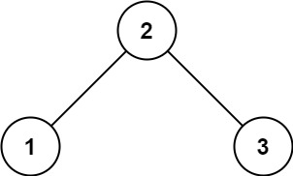
Input: root = [2,1,3]
Output: true
Example 2:
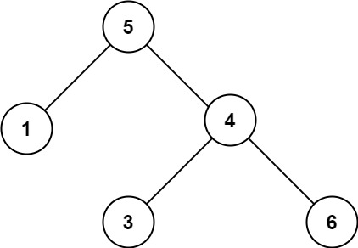
Input: root = [5,1,4,null,null,3,6]
Output: false
Explanation: The root node's value is 5 but its right child's value is 4.

Constraints:
- The number of nodes in the tree is in the range [1, 104].
- -231 <= Node.val <= 231 - 1
- Optimized approach :

bool isValidBSTutil(TreeNode* root,TreeNode* min , TreeNode* max){
if(root==NULL)
return 1;
if(min && root->val<=min->val)
return 0;
if(max && root->val>=max->val)
return 0;
bool isleft = isValidBSTutil(root->left,min,root);
bool isright = isValidBSTutil(root->right,root,max);
return isleft&&isright;

}

bool isValidBST(TreeNode* root) {
TreeNode *min=NULL;
TreeNode *max=NULL;

return isValidBSTutil(root,min,max);

}

Given the head of a linked list, return the node where the cycle begins. If there is no cycle, return null.
There is a cycle in a linked list if there is some node in the list that can be reached again by continuously following the next pointer. Internally, pos is used to denote the index of the node that tail's next pointer is connected to (0-indexed). It is -1 if there is no cycle. Note that pos is not passed as a parameter.
Do not modify the linked list.

Example 1:
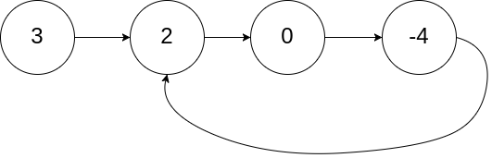
Input: head = [3,2,0,-4], pos = 1
Output: tail connects to node index 1
Explanation: There is a cycle in the linked list, where tail connects to the second node.
Example 2:
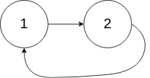
Input: head = [1,2], pos = 0
Output: tail connects to node index 0
Explanation: There is a cycle in the linked list, where tail connects to the first node.
Example 3:

Input: head = [1], pos = -1
Output: no cycle
Explanation: There is no cycle in the linked list.

Constraints:
- The number of the nodes in the list is in the range [0, 104].
- -105 <= Node.val <= 105
- pos is -1 or a valid index in the linked-list.

Follow up: Can you solve it using O(1) (i.e. constant) memory?

Solution : Hair and tortoise approach
after slow and fast matches , start slow from head till it equals==fast

ListNode *detectCycle(ListNode *head) {

if(head==NULL) return NULL;
if(head->next==NULL) return NULL;

ListNode *slow = head;
ListNode *fast = slow;

while(fast && fast->next){
fast = fast->next->next;
slow = slow->next;
if(fast==slow){
slow = head;
break;
}

}
if(fast==NULL || fast->next==NULL) return NULL;
while(fast!=slow){
fast=fast->next;
slow = slow->next;

}

199. Binary Tree Right Side View

Given the root of a binary tree, imagine yourself standing on the right side of it, return the values of the nodes you can see ordered from top to bottom.

Example 1:
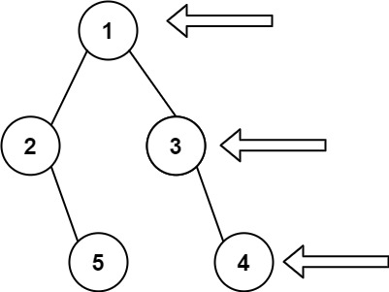
Input: root = [1,2,3,null,5,null,4]
Output: [1,3,4]
Example 2:
Input: root = [1,null,3]
Output: [1,3]
Example 3:
Input: root = []
Output: []

Constraints:
- The number of nodes in the tree is in the range [0, 100].
- -100 <= Node.val <= 100

Solution :

keep track of currentLevel and maxLevel and extract result once currentLevel<=maxLevel (Applicable to both left and right views)

void rightView(TreeNode* root,int currentLevel,int &maxLevel){
if(root==NULL) return;

if(currentLevel>=maxLevel){
result.push_back(root->val);
maxLevel++;
}
rightView(root->right,currentLevel+1,maxLevel);
rightView(root->left,currentLevel+1,maxLevel);

}

